Assignment -3

|  |  |
| --- | --- |
| Assignment Date | 5 October 2022 |
| Student Name | A.Manokaran |
| Student Roll Number | 921319205070 |
| Maximum Marks | 2 Marks |

Question-1:

**Create a Bucket in IBM object storage.**

Solution:

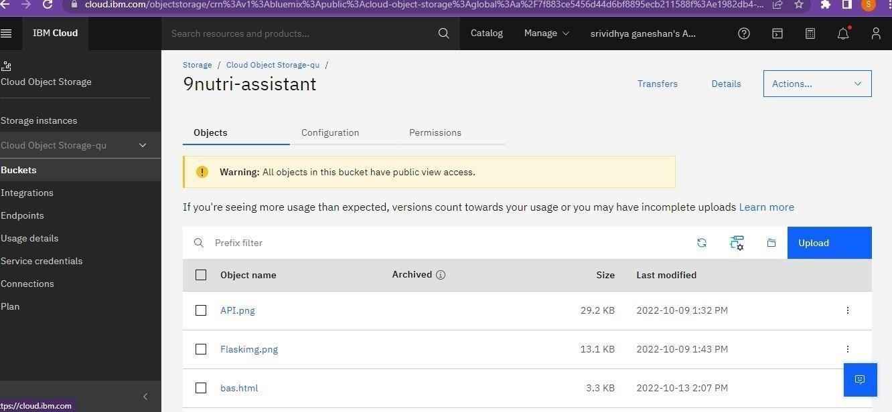

Question-2:

**Upload an 5 images to ibm object storage and make it public. write html code to displaying all the 5 images.**

Solution:

Obj.html

<!DOCTYPE html>

<html>

<head>

<link rel="stylesheet" href="https://9nutri-assistant.s3.jp-tok.cloud-object- storage.appdomain.cloud/styl.css">

</head>

<body>

<img src="https://9nutri-assistant.s3.jp-tok.cloud-object-storage.appdomain.cloud/docker.png" alt="diet" style="width:200px;height:200px;">

<img src="https://9nutri-assistant.s3.jp-tok.cloud-object-storage.appdomain.cloud/API.png" alt="diet" style="width:200px;height:200px;">

<img src="https://9nutri-assistant.s3.jp-tok.cloud-object-storage.appdomain.cloud/Flaskimg.png" alt="diet" style="width:200px;height:200px;">

<img src="https://9nutri-assistant.s3.jp-tok.cloud-object-storage.appdomain.cloud/db2-tutorial.png" alt="diet" style="width:200px;height:200px;">

<img src="https://9nutri-assistant.s3.jp-tok.cloud-object-storage.appdomain.cloud/python.png" alt="diet" style="width:200px;height:200px;">

</body>

</html>

(web url[)https://9nutri-assistant.s3.jp-tok.cloud-object-storage.appdomain.cloud/obj.html](https://9nutri-assistant.s3.jp-tok.cloud-object-storage.appdomain.cloud/obj.html)

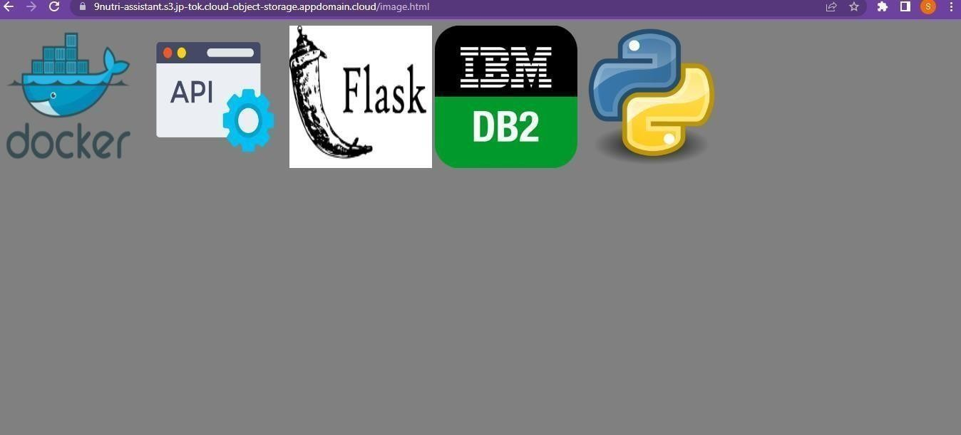

Question-3

**Upload a css page to the object storage and use the same page in your HTML code: Solution: obj.html**

<!DOCTYPE html>

<html>

<head>

<link rel="stylesheet" href="https://9nutri-assistant.s3.jp-tok.cloud-object- storage.appdomain.cloud/styl.css">

</head>

<body>

<img src="https://9nutri-assistant.s3.jp-tok.cloud-object-storage.appdomain.cloud/docker.png" alt="diet" style="width:200px;height:200px;">

<img src="https://9nutri-assistant.s3.jp-tok.cloud-object-storage.appdomain.cloud/API.png" alt="diet" style="width:200px;height:200px;">

<img src="https://9nutri-assistant.s3.jp-tok.cloud-object-storage.appdomain.cloud/Flaskimg.png" alt="diet" style="width:200px;height:200px;">

<img src="https://9nutri-assistant.s3.jp-tok.cloud-object-storage.appdomain.cloud/db2-tutorial.png" alt="diet" style="width:200px;height:200px;">

<img src="https://9nutri-assistant.s3.jp-tok.cloud-object-storage.appdomain.cloud/python.png" alt="diet" style="width:200px;height:200px;">

</body>

</html>

Styl.css body {

background-color:grey;

}

(web url[)https://9nutri-assistant.s3.jp-tok.cloud-object-storage.appdomain.cloud/obj.html](https://9nutri-assistant.s3.jp-tok.cloud-object-storage.appdomain.cloud/obj.html)



Question-4

**Design a chatbot using IBM Watson assistant for hospital. Ex: User comes with query to know the branches for that hospital in your city. Submit the web URL of that chat bot as a assignment:**

Solution:

hospitalbot.html <!doctype

<html>

<html lang="en">

<head>

<!--Required meta tags-->

<meta charset="utf-8">

<meta name="viewport" content="width=device-width,initial-scale=1">

<!--Bootstrap CSS-->

<link hre[f="https:](https://cdn.jsdelivr.net/npm/bootstrap%405.2.1/dist/css/bootstrap.min.css)//c[dn.jsdelivr.net/npm/bootstrap@5.2.1/dist/css/bootstrap.min.css](https://cdn.jsdelivr.net/npm/bootstrap%405.2.1/dist/css/bootstrap.min.css)" rel="stylesheet" integrity="sha384iYQeCzEYFbKjA/T2uDLTpkwGzCiq6soy8tYaI1GyVh/UjpbCx/TYkiZhlZB6+fzT" crossorigin="anonymous">

<script src="[https://cdn.jsdelivr.net/npm/bootstrap@5.2.1/dist/js/bootstrap.bundle.min.js](https://cdn.jsdelivr.net/npm/bootstrap%405.2.1/dist/js/bootstrap.bundle.min.js)" integrity="sha384- u1OknCvxWvY5kfmNBILK2hRnQC3Pr17a+RTT6rIHI7NnikvbZlHgTPOOmMi466C8" crossorigin="anonymous"></script>

<!--<link rel="stylesheet" href="static/css/style.css"-->

</head>

<body>

<nav class="navbar navbar-expand-lg bg-light">

<div class="container-fluid">

<a class="navbar-brand" href="chat">chat</a>

<button class="navbar-toggler" type="button" data-bs-toggle="collapse" data- bstarget="#navbarSupportedContent" aria-controls="navbarSupportedContent" ariaexpanded="false" aria-label="Toggle navigation"> <span class="navbar- toggler-icon"></span>

</button>

<div class="collapse navbar-collapse" id="navbarSupportedContent">

<ul class="navbar-nav me-auto mb-2 mb-lg-0">

<li class="nav-item">

<a class="nav-link active" aria-current="page" href="home">Home</a>

</li>

<li class="nav-item">

<a class="nav-link" href="signup">signup</a>

</li>

<li class="nav-item dropdown">

<a class="nav-link dropdown-toggle" href="#" role="button" data-bs-toggle="dropdown" aria-expanded="false">

Dropdown

</a>

<ul class="dropdown-menu">

<li><a class="dropdown-item" href="about">About</a></li>

<li><a class="dropdown-item" href="blog">blog</a></li>

<li><hr class="dropdown-divider"></li>

<li><a class="dropdown-item" href="signin">Signin</a></li>

</ul>

</li>

<li class="nav-item">

<a class="nav-link disabled">disabled</a>

</li>

</ul>

<form class="d-flex" role="search">

<input class="form-control me-2" type="search" placeholder="Search" arialabel="Search">

<button class="btn btn-outline-success" type="submit">Search</button>

</form>

</div>

</div>

</nav>

<div class="container mt-5">

</div>

<script>

window.watsonAssistantChatOptions = { integrationID: "517f465d-2977-465f-899b- c4b94ad970e2", // The ID of this integration. region: "jp-tok", // The region your integration is hosted in.

serviceInstanceID: "a8fd5579-a080-4040-8bfb-f586e4399ce4", // The ID of your service instance.

onLoad: function(instance) { instance.render(); }

};

setTimeout(function(){

const t=document.createElement('script');

t.src="https://web-chat.global.assistant.watson.appdomain.cloud/versions/" + (window.watsonAssistantChatOptions.clientVersion || 'latest') + "/WatsonAssistantChatEntry.js";

document.head.appendChild(t);

});

</script>

</body>

</html> (weburl) [https://9nutri-assistant.s3.jp-tok.cloud-object-](https://9nutri-assistant.s3.jp-tok.cloud-object-storage.appdomain.cloud/hospitalbot.html)

[storage.appdomain.cloud/hospitalbot.html](https://9nutri-assistant.s3.jp-tok.cloud-object-storage.appdomain.cloud/hospitalbot.html)

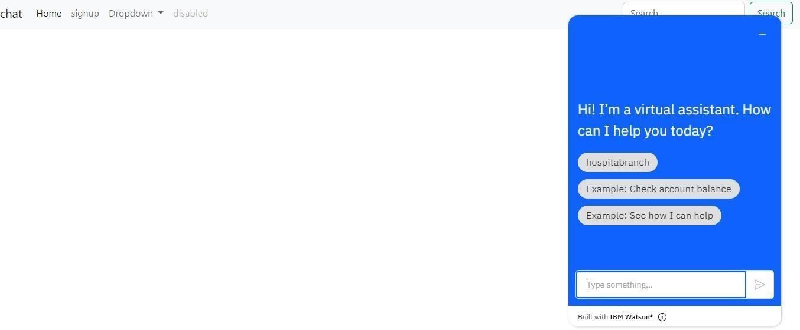

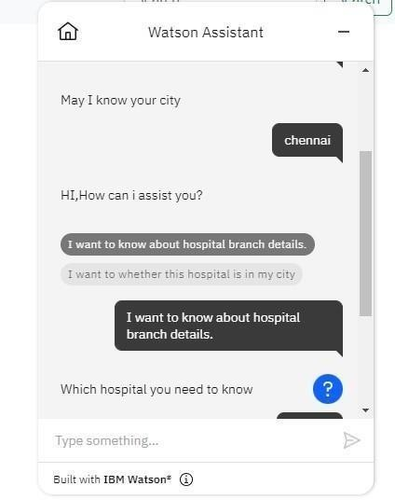

Question-5:

**Create Watson assistant service with 10 steps and use 3 conditions in it. Load that script in HTML page.**

Solution: bas.html

<!doctype html>

<html lang="en">

<head>

<!--Required meta tags-->

<meta charset="utf-8">

<meta name="viewport" content="width=device-width,initial-scale=1">

<!--Bootstrap CSS-->

<link hre[f="https:](https://cdn.jsdelivr.net/npm/bootstrap%405.2.1/dist/css/bootstrap.min.css)//c[dn.jsdelivr.net/npm/bootstrap@5.2.1/dist/css/bootstrap.min.css](https://cdn.jsdelivr.net/npm/bootstrap%405.2.1/dist/css/bootstrap.min.css)" rel="stylesheet" integrity="sha384-

iYQeCzEYFbKjA/T2uDLTpkwGzCiq6soy8tYaI1GyVh/UjpbCx/TYkiZhlZB6+fzT" crossorigin="anonymous">

<script src[="http](https://cdn.jsdelivr.net/npm/bootstrap%405.2.1/dist/js/bootstrap.bundle.min.js)s:[//cdn.jsdelivr.net/npm/bootstrap@5.2.1/dist/js/bootstrap.bundle.min.js](https://cdn.jsdelivr.net/npm/bootstrap%405.2.1/dist/js/bootstrap.bundle.min.js)" integrity="sha384- u1OknCvxWvY5kfmNBILK2hRnQC3Pr17a+RTT6rIHI7NnikvbZlHgTPOOmMi466C8" crossorigin="anonymous"></script>

<!--<link rel="stylesheet" href="static/css/style.css"-->

</head>

<body>

<nav class="navbar navbar-expand-lg bg-light">

<div class="container-fluid">

<a class="navbar-brand" href="chat">chat</a>

<button class="navbar-toggler" type="button" data-bs-toggle="collapse" data- bstarget="#navbarSupportedContent" aria-controls="navbarSupportedContent" ariaexpanded="false" aria-label="Toggle navigation"> <span class="navbar- toggler-icon"></span>

</button>

<div class="collapse navbar-collapse" id="navbarSupportedContent">

<ul class="navbar-nav me-auto mb-2 mb-lg-0">

<li class="nav-item">

<a class="nav-link active" aria-current="page" href="home">Home</a>

</li>

<li class="nav-item">

</li>

<li class="nav-item dropdown">

<a class="nav-link dropdown-toggle" href="#" role="button" data-bs-toggle="dropdown" aria-expanded="false">

Dropdown

</a>

<ul class="dropdown-menu">

<li><a class="dropdown-item" href="about">About</a></li>

<li><a class="dropdown-item" href="blog">blog</a></li>

<li><hr class="dropdown-divider"></li>

<li><a class="dropdown-item" href="signin">Signin</a></li>

</ul>

</li>

<li class="nav-item">

<a class="nav-link disabled">disabled</a>

</li>

</ul>

<form class="d-flex" role="search">

<input class="form-control me-2" type="search" placeholder="Search" arialabel="Search">

<button class="btn btn-outline-success" type="submit">Search</button>

</form>

</div>

</div>

</nav>

<div class="container mt-5">

</div>

<script>

window.watsonAssistantChatOptions = { integrationID: "231da11b-5283-449c- a7a9-8dfc4a571a0d", // The ID of this integration. region: "jp-tok", // The region your integration is hosted in.

serviceInstanceID: "a8fd5579-a080-4040-8bfb-f586e4399ce4", // The ID of your service instance. onLoad: function(instance) { instance.render(); }

};

setTimeout(function(){ const t=document.createElement('script');

t.src="https://web-chat.global.assistant.watson.appdomain.cloud/versions/" + (window.watsonAssistantChatOptions.clientVersion || 'latest') + "/WatsonAssistantChatEntry.js";

document.head.appendChild(t);

});

</script>

</body>

</html>

**(Web url)** <https://9nutri-assistant.s3.jp-tok.cloud-object-storage.appdomain.cloud/bas.html>

